

**BILLING SYSTEM**

**TEAM - 3**

**RITHESH**

**NUTHAN**

**SANJAY**

**ARCHITH**

**MEGHANA**

**PRAMOD**

**December 2, 2022**

Table Of Contents:

1. PROBLEM STATEMENT…………………………………………2

2. INTRODUCTION………………………………………………….2

3.OBJECTIVES AND GOALS……………………………………….3

4. REQUIREMENTS………………………………………………….4

5. DESIGNING……………………………………………………….5-8

6. FUNCTIONALITIES………………………………………………9-11

7. WORKING PROCEDURE…………………………………………12

8. TESTING……………………………………………………………13

9. WORKFLOW…………….…………………………………………19

**BILLING SYSTEM**

Problem Statement:

Nowadays, in shopping malls we must wait for the billing in a long queue, it accrues traffic in a mall, and it is a very time-consuming process. So, there is a need to design a system that will reduce the time of billing procedure.

Introduction:

Nowadays shopping has become a daily activity in today’s world. One can see a huge rush at shopping malls on holidays, peak hours of the day and on special discount days. People purchase different items, put them in trolleys, and go to the billing counter for payments. So, now the problem is that the customers must wait in long queues to complete the payment process to check out their products. Hence, it is tedious and time consuming. To provide the customer with enhanced shopping experience we have designed a smart and effective way to shop at the supermarket. The system designed is technology oriented, time saving and commercial oriented system. After getting the products from the store, customers can generate their own bill using the web app. In the web app they can select the product which they have collected in the store and complete the payment process where they’ll get bill.

Goals:

* User friendly
* Simple and Fast
* Low cost and effective

Objectives:

* To reduce the time of the billing procedure
* To reach maximum customers at the right time
* To increase sales and profitability of the business

System Requirements:

* Spring Tool suite
* Java,
* H2 Database
* HTML , CSS , Js
* Tom cat server
* Maven
* JIRA

Spring Tool suite:

Spring Tool Suite (STS) is **a java IDE tailored for developing Spring-based enterprise applications**. It is easier, faster, and more convenient. And most importantly it is based on Eclipse IDE

Java:

Java is **the official language for Android mobile app development**.

H2 Data base:

H2 is **an open-source lightweight Java database**. It can be embedded in Java applications or run in the client-server mode.

HTML , CSS , JS:

* HTML is the code that is used **to structure a web page and its content**
* CSS is **the language for describing the presentation of Web pages, including colors, layout, and fonts**
* JS is used by programmers across the world **to create dynamic and interactive web content like applications and browsers**.

Tom Cat server:

Apache Tomcat is a web container. It **allows the users to run Servlet and JAVA Server Pages that are based on the web-applications**.

Maven:

Maven is used for building**, publishing, and deploying several projects**.

JIRA: Jira **helps teams plan, assign, track, report, and manage work and brings teams together for everything from agile software development and customer support to start-ups and enterprises**

DESIGN PATTERN:

**Use Case** is a written description of how users will perform tasks on your website.

FLOW CHART:

**Flowchart** is a picture of the separate steps of a process in sequential order.

UML CLASS:

**Class** diagrams are the blueprints of your system or subsystem.

ER DIAGRAM:

**ER** diagram is a type of flowchart that illustrates how “entities” such as people, objects or concepts relate to each other within a system.

FUNCTIONAL REQUIREMENT:

This subsection presents the identified functional requirements for the subject Billing System. Initially, general requirements that pertain to the whole system are given.

# Customer

Table presents the identified functional customer requirements that directly relate to the customers of the Billing System.

|  |  |
| --- | --- |
| **REQUIREMENT** | **DESCRIPTION** |
| 01 | A customer shall be able to register to application using the credentials |
| 02 | A customer shall be able to login to application |
| 03 | A customer shall be able to view the list of products |
| 04 | A customer shall be able to view the products based on the categories |
| 05 | A customer shall be able to add items to the cart |
| 06 | A customer shall be able to remove the products from the cart |
| 07 | A customer shall be able to pay the bill by selecting the payment options |
| 08 | A customer shall be able to view the Generated Bill after payment is done |
| 09 | A customer shall be able to download the generated bill. |
| 10 | A customer shall be able to Logout from the webpage. |

USECASE DESCRIPTIONS:

Table presents the Registration use case description to show the interaction of Actors when logging into the system.

|  |  |
| --- | --- |
| Use Case | Registration page |
| Primary Actor | Customer |
| Goal In Context | Enable Actor to get registered to the system through an app |
| Preconditions | The Actors must provide a valid username and password to get registered |
| Scenario | 1. The Actors selects ‘registration’ from the app menu 2. The app prompts the user for their username and password 3. The Actors enters their username and password 4. The app registers the new users in it. |
| Exceptions | The Actors enters an invalid username or password |

**Table :Registration Use Case Description**

Table presents the Registration use case description to show the interaction of Actors when logging into the system.

|  |  |
| --- | --- |
| Use Case | Log In |
| Primary Actor | Customer |
| Goal In Context | Enable Actors access to the system through an app |
| Preconditions | The Actors must provide a valid username and password to get logged in |
| Scenario | 1. The Actors selects ‘Log-In’ from the app menu 2. The app prompts the user for their username and password 3. The Actors enters their username and password 4. The app enables access to the system according to access control |

**Table: Log In Use Case Description**

Table presents the List of Products use case description to show the interaction of Actors to view the products

|  |  |
| --- | --- |
| Use Case | PRODUCTS LIST |
| Primary Actor | Customer |
| Goal In Context | Enable Actors to view the products listed |
| Preconditions | The customer has been set up the applications |
| Scenario | 1. The customer brings up a products list 2. The customer selects 'Products' from the List 3. The customer selects 'Add to Cart’ from the Listing page |

**Table: Products List Use Case Description**

Table presents the’ Cart ‘ use case description to show the interaction of Actors to view the products that are been selected from the List

|  |  |
| --- | --- |
| Use Case | Cart |
| Primary Actor | Customer |
| Goal In Context | Enable Actors to view the selected products from the products list. |
| Preconditions | A customer has selected the products to the cart |
| Scenario | 1. The customer brings up a products list in the cart 2. The customer can increase or decrease the quantity of 'Products' from the List 3. The customer selects ‘Payment’ to pay the bill. |

**Table: Cart Use Case Description**

Table presents the ‘Pay now’ use case description to show the interaction of Actors to pay the bill .

|  |  |
| --- | --- |
| Use Case | Pay now |
| Primary Actor | Customer |
| Goal In Context | Pay the bill |
| Preconditions | A customer has selected the Pay now to pay the Bill |
| Scenario | 1. The customer selects the payment mode 2. The customer fills in the payment details to pay. |

**Table: Pay Now Use Case Description**

Table presents the ‘Generate Bill’ use case description to show the interaction of Actors to view the generated bill .

|  |  |
| --- | --- |
| Use Case | Bill |
| Primary Actor | Customer |
| Goal In Context | Generate Bill |
| Preconditions | A customer has selected the Bill after payment |
| Scenario | 1. The customer selects the Bill option 2. The customer can view the generated bill 3. The customer can download the generated bill. |

**Table: Bill Generation Use Case Description**

WORKING PROCEDURE:

Steps : -

1. Customer will enter Supermarket and take Products in trolley which they want to buy and will open Supermarket’s App.

2. Customer will have to register on App by clicking on Registration Page button and will have to enter Username, email and password.

3.After Registering on App, Customer will click on Login page button where Customer will have to enter their credentials in Login Form and verify themselves.

4. After Successful Login, Customer will be taken to Product Page which has list of Products, and they will add Products to Cart which they have taken in trolley by clicking add to cart button below each Product.

5. After adding Products, Customer will click on Cart button which will show Products added in cart.

6. After checking Cart, Customer will click on Payment Section button and payment page will appear.

7. Customer can pay either using Card or PayPal Account.

8.After entering credentials, Customer will click on Pay Now button.

9.After Successful completion of payment, Generate Bill button will appear. After clicking on button bill will be generated and by clicking on bill button, customer can see bill.

10. For downloading bill, Customer can click on Download button and bill will be downloaded. Customer will show bill to Security person and come out of Supermarket.

|  |  |  |  |  |  |
| --- | --- | --- | --- | --- | --- |
| **Test Case ID** | 1 | **Test Case Description** | Test the Functionalities in Supermarket Application | | |
| **Created By** | Team 3 | **Reviewed By** |  | **Version** |  |
|  | | | | | |
| **QA Tester’s Log** |  |  | | | |
|  | | | | | |
|  | | | | | |
| **Tester's Name** | Team 3 | **Date Tested** | 29-11-2022 | **Test Case (Pass/Fail/Not Executed)** | Pass |

TEST CASES:

|  |  |  |  |  |
| --- | --- | --- | --- | --- |
|  | | | | |
| **Test Scenario 01:** | To verify whether the registration of the customer is successful | | | |
|  | | | | |
| **Step #** | **Step Details** | **Expected Results** | **Actual Results** | **Pass / Fail / Not executed / Suspended** |
|  |
| 1 | Navigate to http://localhost:8080/registration | Registration page should open | Registration Page has successfully opened | Pass |  |
| 2 | Enter the Customer's name, username and password | Customer should be able to enter the credentials | Credentials have been entered successfully | Pass |  |
| 3 | Click on Register | Customer should be able to register with the application | Customer has been registered successfully | Pass |  |
| 4 | Click on Login | Customer should be able to navigate to Login page | Customer has been navigated to the Login page successfully | Pass |  |
|  | | | | |  |

|  |  |  |  |  |
| --- | --- | --- | --- | --- |
| **Test Scenario 02:** | To verify whether the Login of the customer is successful | | | |
|  | | | | |
| **Step #** | **Step Details** | **Expected Results** | **Actual Results** | **Pass / Fail / Not executed / Suspended** |
|  |
| 1 | Navigate to http://localhost:8080/login | Login page should open | Login Page has successfully opened | Pass |  |
| 2 | Enter the Customer's username and password | Customer should be able to enter the credentials | Credentials have been entered successfully | Pass |  |
| 3 | Click on Login | Customer's credentials should be verified and should navigate to home page | Customer's credentials has been verified and navigated to home page | Pass |  |
| 4 | Click on Login with invalid credentials entered | Customer's credentials should be verified and should display invalid credentials entry | Customer's credentials has been verified and it displayed invalid credentials entry | Pass |  |
| 5 | Click on Register if not registered | Customer should be able to navigate to Registration page | Customer has been navigated to the Registration page successfully | Pass |  |
|  | | | | |  |

|  |  |  |  |  |
| --- | --- | --- | --- | --- |
| **Test Scenario 03:** | To verify the functionality of the products listing in the home page | | | |
|  | | | | |
| **Step #** | **Step Details** | **Expected Results** | **Actual Results** | **Pass / Fail / Not executed / Suspended** |
|  |
| 1 | Listing of all Products | Products should be listed according to their categories along with the description and price | Products have been listed according to their categories along with the description and price | Pass |  |
| 2 | Listing of Products based on the categories of customers preference | Products of a particular category should be displayed on selecting that particular category | As Expected | Pass |  |

|  |  |  |  |  |
| --- | --- | --- | --- | --- |
| **Test Scenario 04:** | To verify the functionality of the cart in the home page | | | |
|  | | | | |
| **Step #** | **Step Details** | **Expected Results** | **Actual Results** | **Pass / Fail / Not executed / Suspended** |
|  |
| 1 | Adding products to the cart | The selected products should be added to the cart based on the customers prefernce | The selected products have been added to the cart based on the prefernce | Pass |  |
| 2 | Click on Cart | The cart items should be displayed along with the quantity of the products added | The cart items have been displayed along with the quantity of the products added | Pass |  |
| 3 | Click on increase/decrease quantity of the product | The quantity of the selected product in the cart should be increased or decreased based on the needs | As Expected | Pass |  |
| 4 | Display the total price of the cart | The total price of the cart should be updated and displayed as and when the cart is modified | The total price of the cart has been updated and displayed as and when the cart is modified | Pass |  |
| 5 | Remove the products from the cart | The selected product should be removed from the cart based on the customers preferences | The selected product have been removed from the cart successfully | Pass |  |
| 6 | Clear cart | The clear cart should remove all the selected products from the cart | The clear cart has been removed all the selected products from the cart successfully | Pass |  |

|  |  |  |  |  |
| --- | --- | --- | --- | --- |
| **Test Scenario 05:** | To verify the functionality of the Payment in the cart | | | |
|  | | | | |
| **Step #** | **Step Details** | **Expected Results** | **Actual Results** | **Pass / Fail / Not executed / Suspended** |
|  |
| 1 | Click on Payment section | The Custemor should view the payment options and able to select the required one | The payment options have been viewed and abled to select the required one | Pass |  |
| 2 | Selecting the payment option | On selecting the payment option the customer should be able to pay the Bill by entering the payment details | The required payment has been selected and abled to pay the bill | Pass |  |
| 3 | Click on Pay now | On completion of the payment ,the payment successful message should be displayed | The payment successful message has been displayed after the payment is done | Pass |  |
| 4 | Click on Generate Bill | The Customer should be able to access the bill button on the home page | The Customer has been able to access the bill button on the home page | Pass |  |

|  |  |  |  |  |
| --- | --- | --- | --- | --- |
| **Test Scenario 06:** | To verify the functionality of the generate Bill in the home page | | | |
|  | | | | |
| **Step #** | **Step Details** | **Expected Results** | **Actual Results** | **Pass / Fail / Not executed / Suspended** |
|  |
| 1 | Click On Bill | The Customer should view the generated bill with products detail and price with the total price and the GST added to it. | The Bill has been generated with all the required details in it | Pass |  |
| 2 | Click On Download Bill | the customer should able to download the generated bill | The Generated Bill has been downloaded successfully | Pass |  |

|  |  |  |  |  |
| --- | --- | --- | --- | --- |
| **Test Scenario 07:** | To verify the functionality of the Logout option in the home page | | | |
|  | | | | |
| **Step #** | **Step Details** | **Expected Results** | **Actual Results** | **Pass / Fail / Not executed / Suspended** |
|  |
| 1 | Click On LogOut | The Customer should be able Logout from the application | The customer has been successfully Logged out | Pass |  |

WORKFLOW:

**Requirements:**

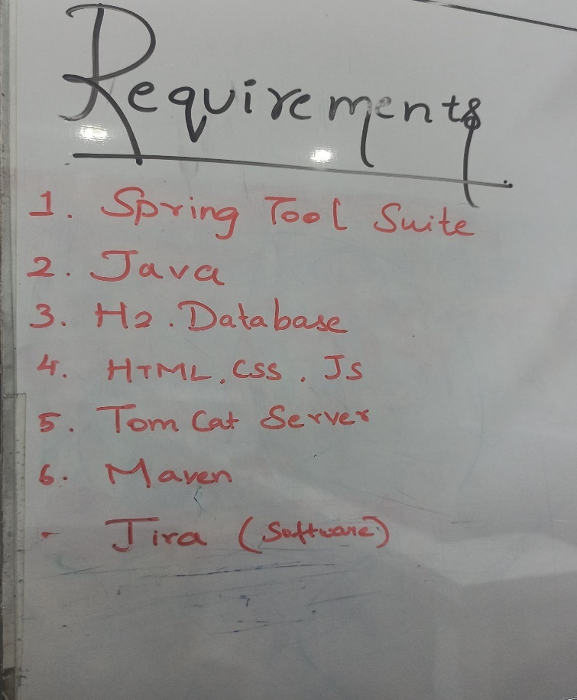

**UserStories:**

**Flow Chart:**

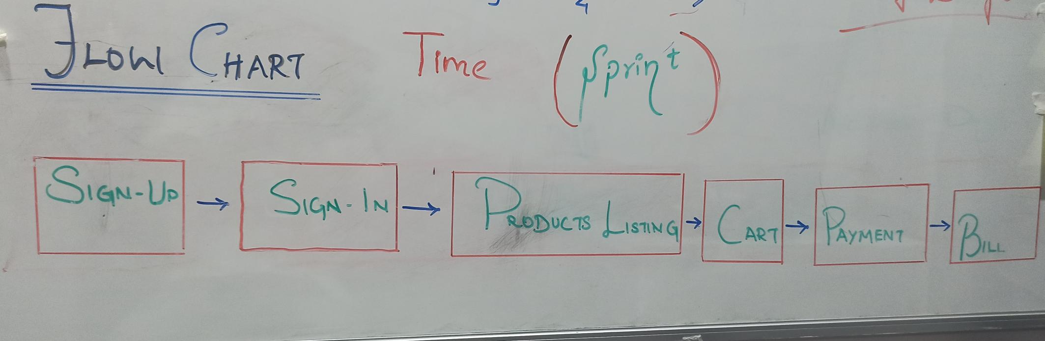

**Task Board:**

**Burn Down :**

**Burn Down Chart**



